192524282-P.SHASHANK
EXP:7
SELECT with various clause – GROUP BY, HAVING, ORDER BY
GROUP BY - HAVING
1. Display the course description and number of students registered in each course
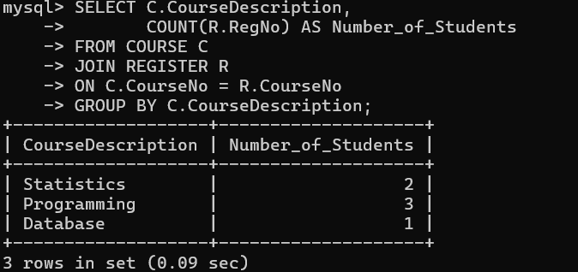
2. Display the number of courses registered by each student
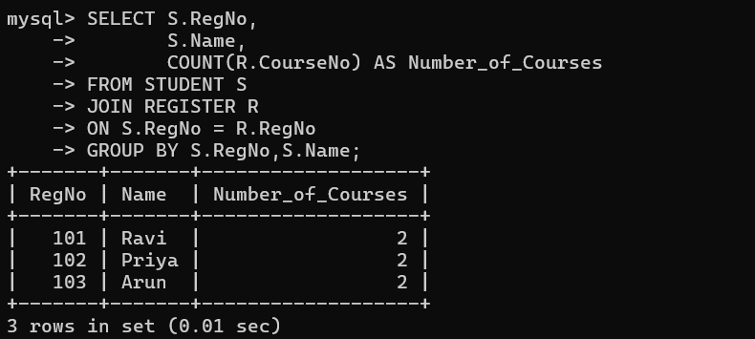

HAVING Example
Display courses having more than one student.
